MUNDa JULY feedback (28/07/2026)

- What is the “Type” in Image Metadata for?
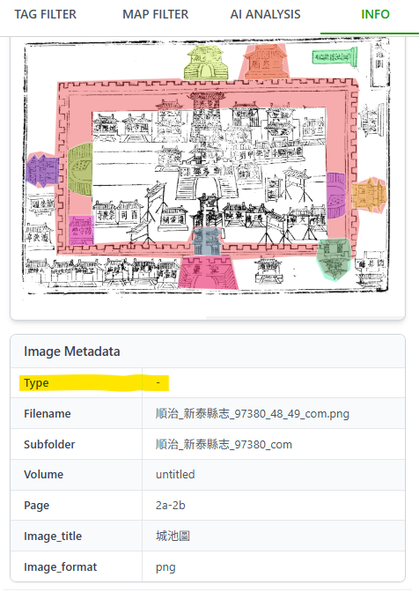
For reference: Image Metadata field list shown in X-MARKUS. The upper chunk is folder metadata; the lower one is image metadata.
It has been resolved.
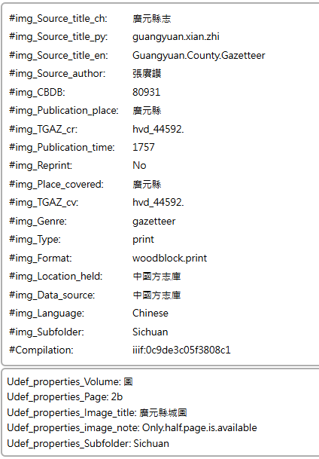
Metadata info for the same record in MUNDa shows far less contents:
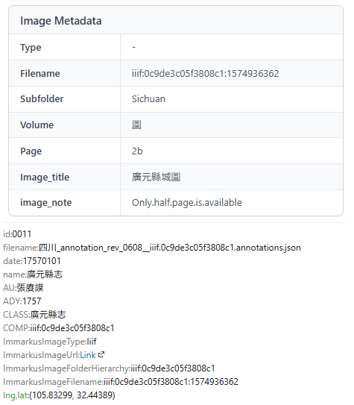
It's been resolved. Please let me know if any fields are missing.

- Allow user to define or edit the layer name when exporting filtered data to a new layer. The current auto-generated names are not intuitive and can make layer management difficult.
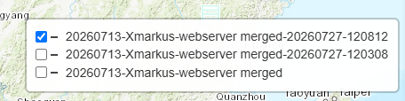
It's been resolved.
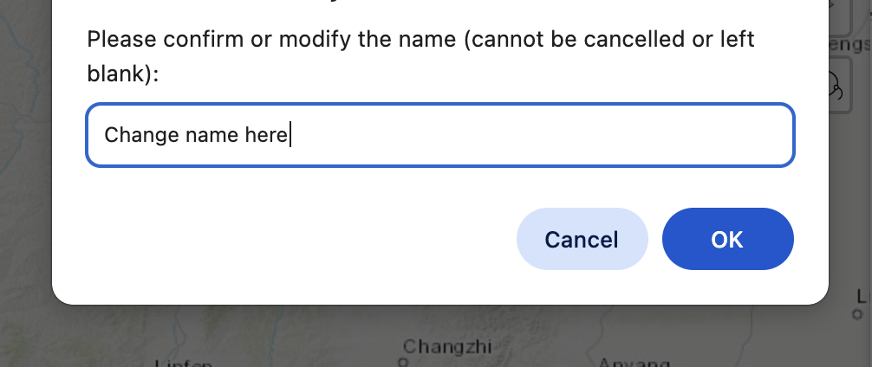
- The entity class information still includes entity IDs. Instead, it would be clearer to display the class hierarchy (e.g., “object / city_wall”) without the ID.
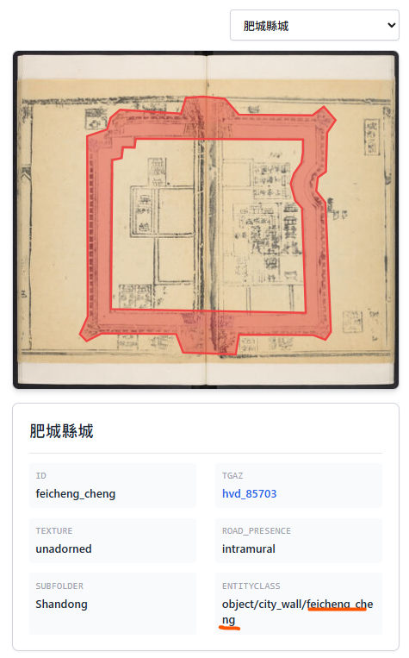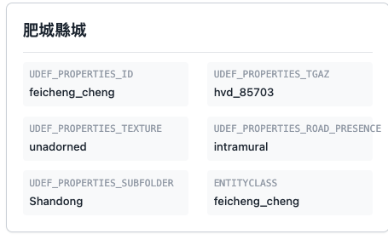
It's been resolved.
- The sequence/order of image filters appears unchanged. Entity classes (object; obj_part; landform; water) should be displayed on top of the list. 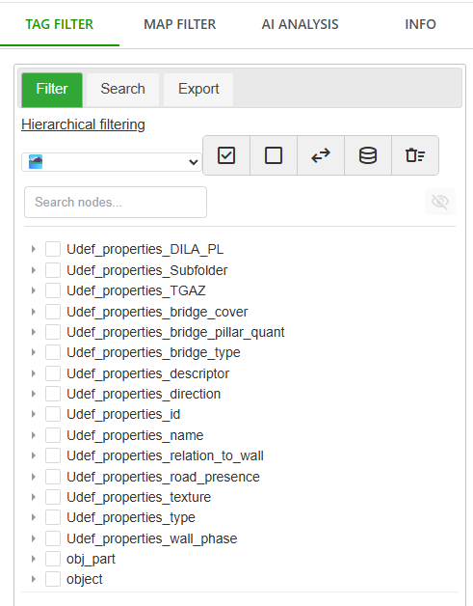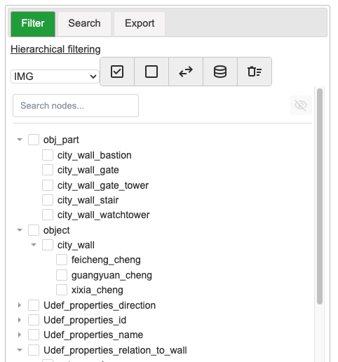
It's been resolved.
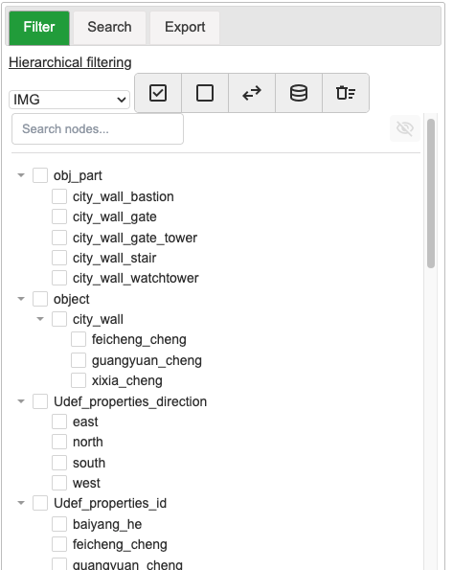
- Filter categorization for image corpus in dropdown menus: In the filter dropdown menu, it would be helpful to explicitly show filter categories (e.g., “Entity Class”, “Property”) and provide corresponding sub-options based on the selected category.
Thinking about how to solve this?

- Make image filter prefix default as “IMG”
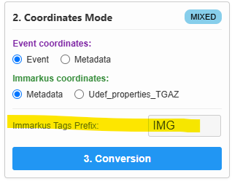
It's been resolved.
- Inconsistency between hierarchical and advanced filters for image corpus
There is a structural inconsistency between the hierarchical filter and the advanced filter:
- In the hierarchical filter, entities follow a clear structure such as:
object → city_wall → specific Ids:
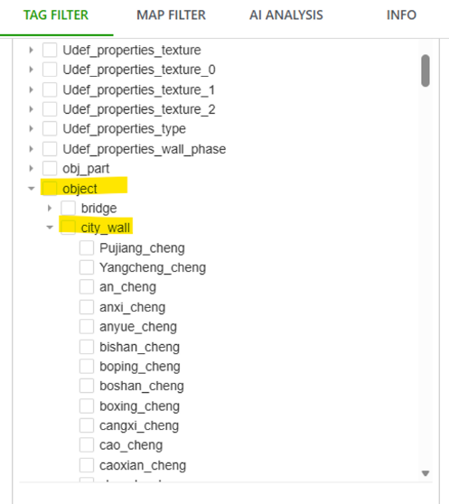
- In the advanced filter, subcategories like obj_part: bridge_gate appear at the same level as object:
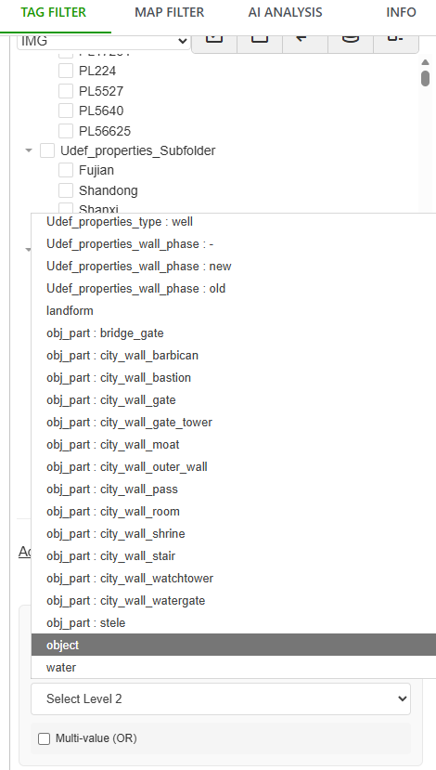
- Intermediate levels (e.g., “bridge”, “city_wall”) are missing under object, resulting in all IDs being displayed directly at level 3 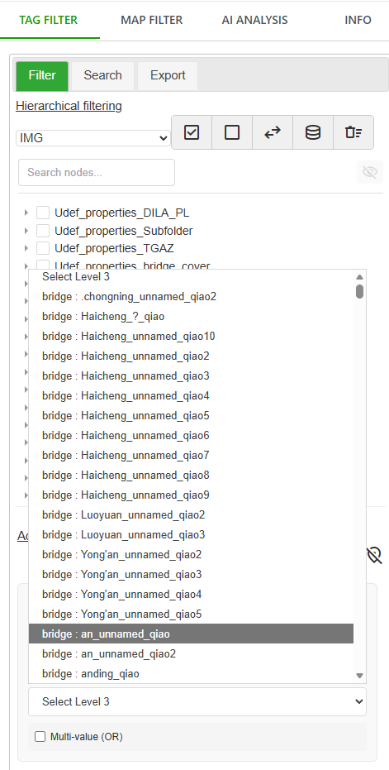
This creates usability challenges. For example, users cannot easily filter “all city walls with flag_stone texture.” Currently selecting all city_wall entities requires manually checking each individual ID, which is inefficient.
A temporary workaround is to apply filters step-by-step using the hierarchical filter and export each step as a new layer, but this approach is not user-friendly.
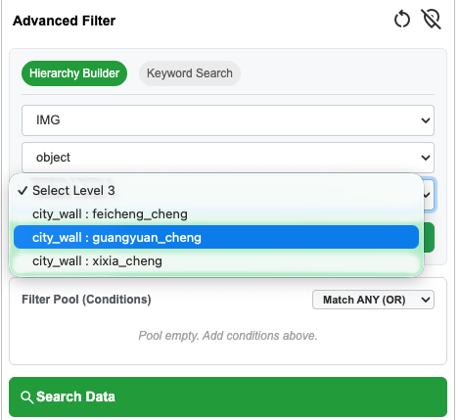
Redesign the logic to solve these problems. It's been resolved.

- Incomplete options in hierarchical filter
In the advanced filter dropdown, categories such as “water” and “landform” are available:
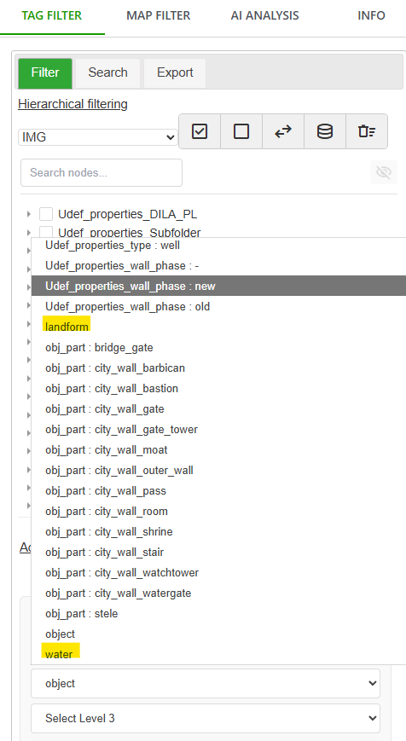
These categories do not appear in the hierarchical filter:
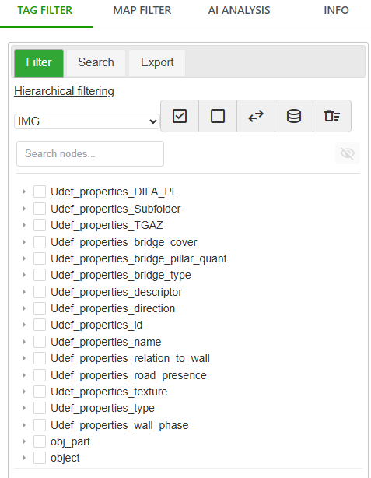
Redesign the logic to solve these problems. It's been resolved.

